EDUR 9131
Illustrated Statistical Analyses

1. Data Description
- Data collected from 500+ undergraduate students at Georgia Southern
- Study focus was on cyber-harassment
- Analyses that follow will focus on the following variables: student sex, academic functioning, and life functioning
- Academic Functioning consists of
  - GPA
  - Graduation Confidence
  - University Connectedness
  - Academic Control
  - Intrinsic Motivation
  - Identified Regulation
- Life Functioning consists of
  - Toxic Disinhibition
  - Impulsivity
  - Empathy
  - Stress
  - Life Satisfaction
  - Socially Connected
- Counts of victimization and perpetration among respondents: VictimCount, BullyCount
- Measurement of each variable is shown below

Academic Functioning

Student Sex

GPA
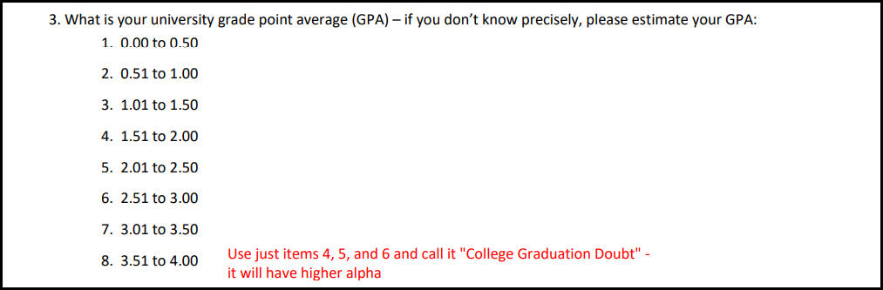

Graduation Confidence
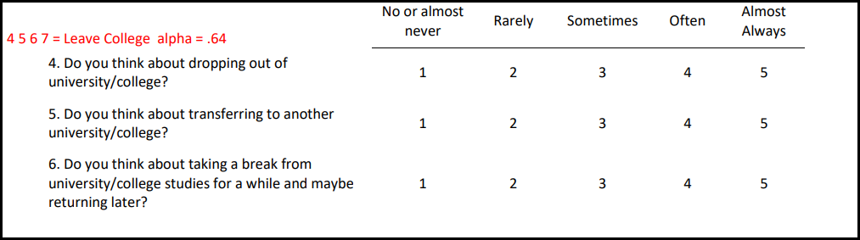
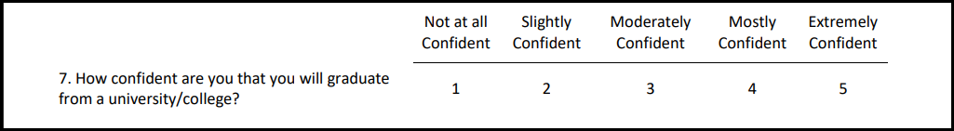

University Connectedness
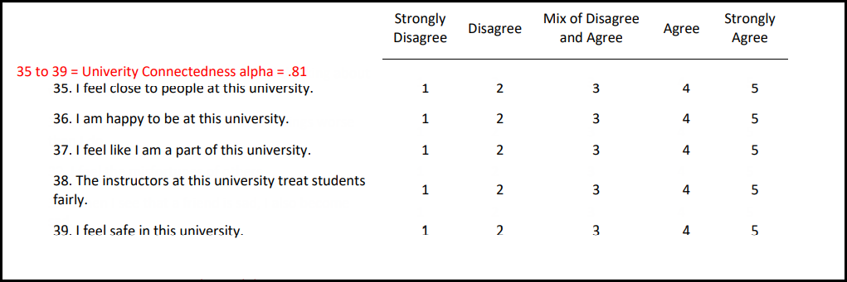

Intrinsic Motivation and Identified Regulation
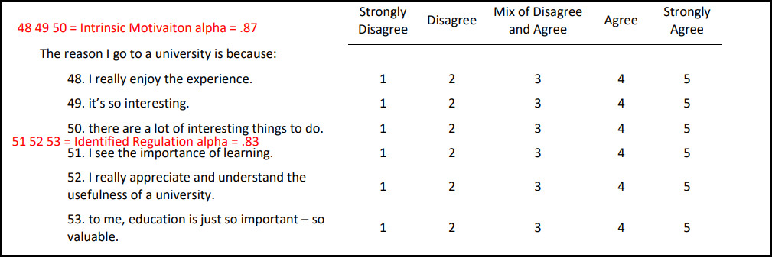

Academic Control
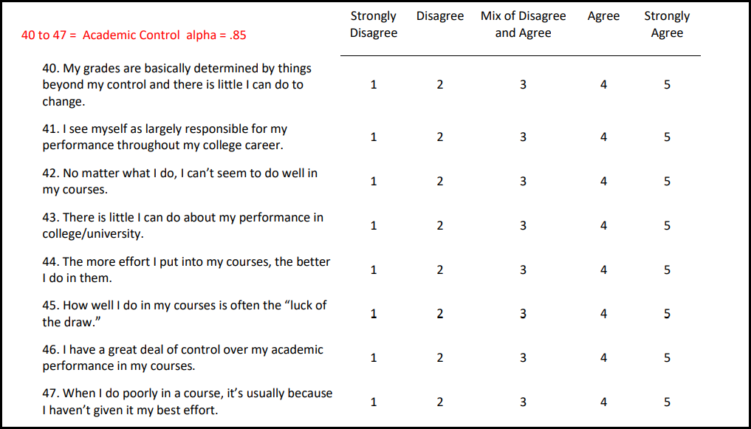

Life Functioning

Empathy
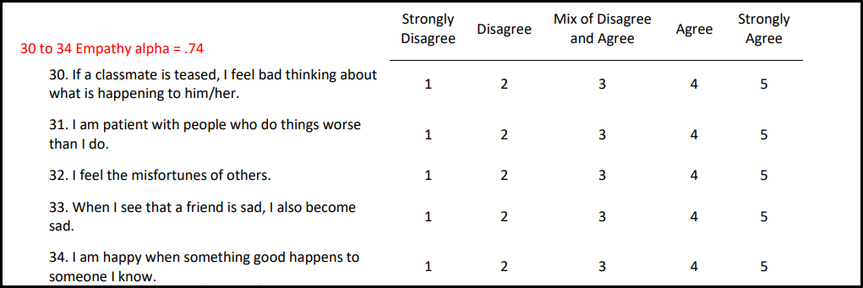

Toxic Disinhibition
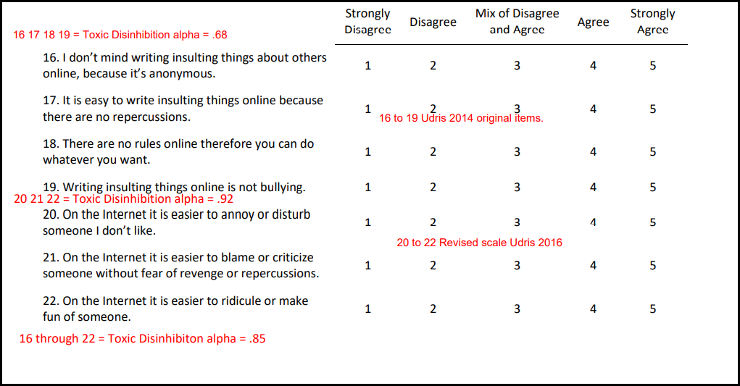

Impulsivity
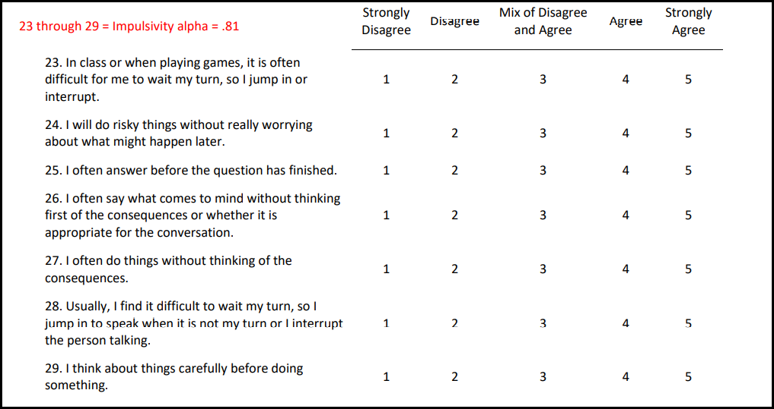

Stress
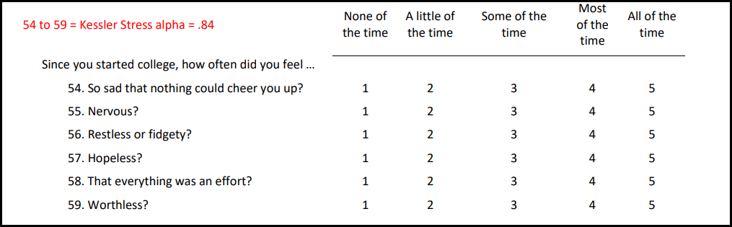

Life Satisfaction and Socially Connected
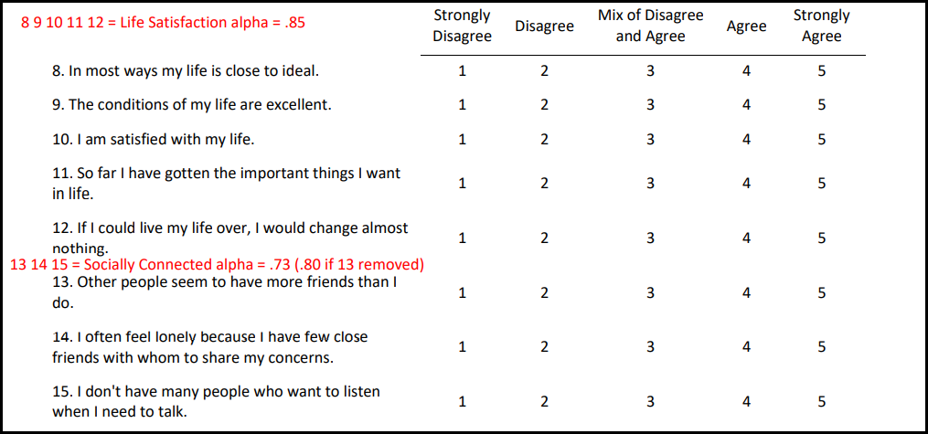

Victim Count and Bully Count (spoken harassment example, also includes written, visual, hacking/impersonating, and social harassment)
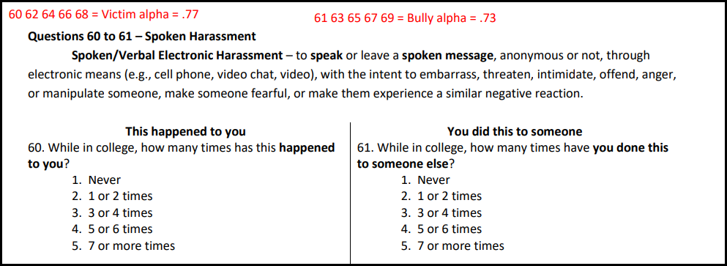

2. Theoretical Models to Explore

Correlation Model

Which Life Functioning variables correlate with cyber-harassment bullying behavior?

Hypothesize how each may correlate with cybr-bullying behavior.

Analyze with correlation and test your hypotheses.

Life Functioning variables
  - Socially Connected
  - Impulsivity
  - Empathy
  - Stress
  - Toxic Disinhibition
  - Life Satisfaction

Regression Models

College Graduation Confidence

What relationship do you predict – hypothesize – between College Graduation Confidence and each of the predictors below?

Analyze with regression and test your hypotheses.

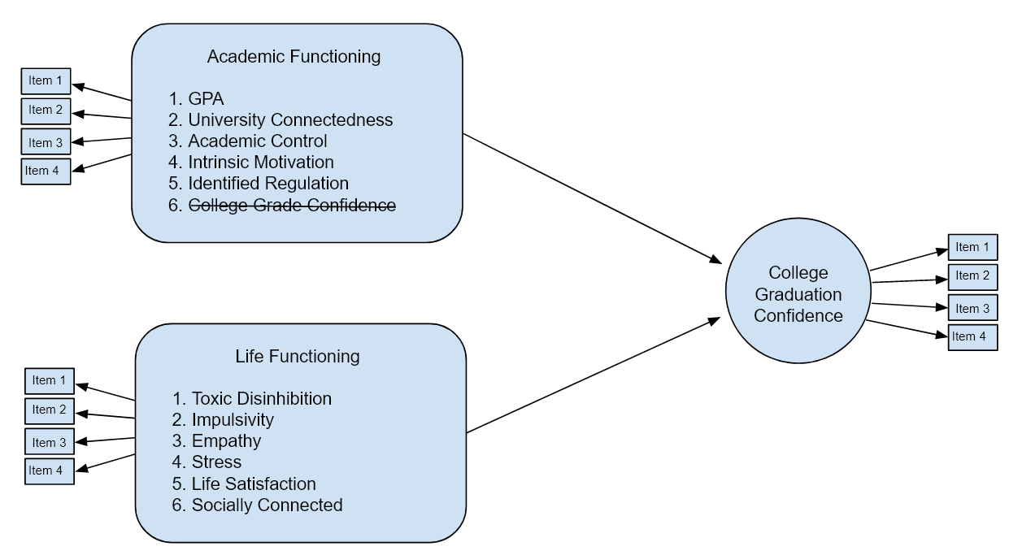

Life Satisfaction

What relationship do you predict – hypothesize – between College Graduation Confidence and each of the predictors below?

Analyze with regression and test your hypotheses.

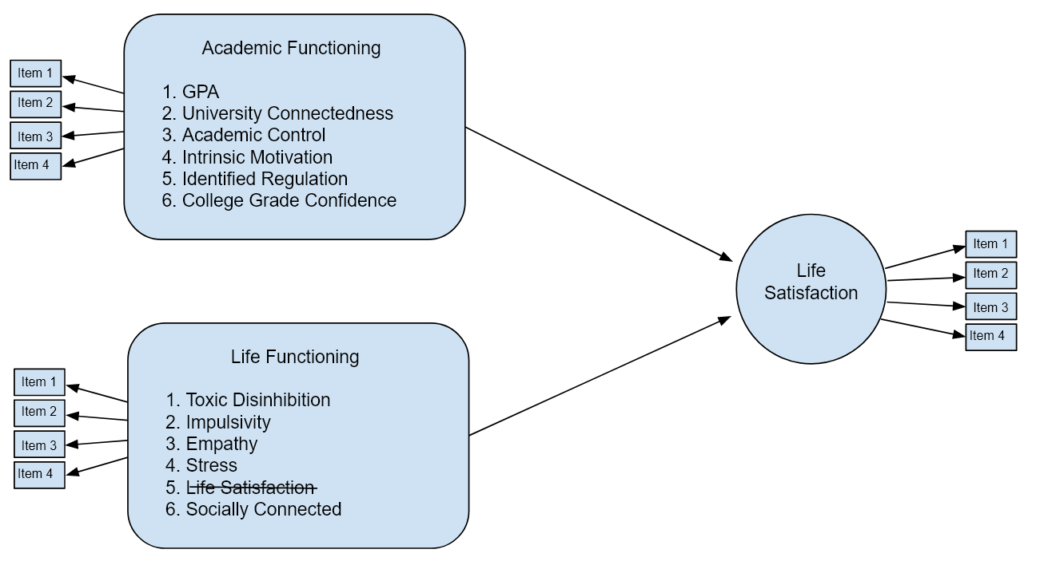

3. Results in APA Style

To be done in class.

A. Frequencies and Descriptive Statistics

(1) What is the count (frequency) of respondents by cyberharassment experience?

Variable: HarassGroup
Codes:
- 1 = No experience with cyberharassment
- 2 = Victim
- 3 = Victim and Perpetrator

Note, must convert HarassGroup to Nominal scale in JASP to obtain frequencies.

In JASP, use Descriptives command. Select under Tables to find Frequencies.
In SPSS, use Frequencies command.

(2) What is the level of AF_CollegeGradConf (college graduation confidence) by HarassGroup?

Report Mean, Median, SD, and Variance by group.

In JASP, use Descriptives command. Use Split option to see statistics by group.
In SPSS, use Explore command or Tables, Basic Tables.

B. Cyber-harassment Bullying Correlations

Which Life Functioning variables correlate with cyber-harassment bullying behavior?
Hypothesize how each may correlate with might this correlate with bullying behavior?

Life Functioning variables
  - Socially Connected
  - Impulsivity
  - Empathy
  - Stress
  - Toxic Disinhibition
  - Life Satisfaction

Table 1: Descriptive Statistics and Correlations for Cyber-harassment Data
Variable | 1 | 2 | 3 | 4 | 5 | 6 | 7
1. CH Bullying
2. Socially Connected
3. Impulsivity
4. Empathy
5. Stress
6. Toxic Disinhibition
7. Life Satisfaction
Mean
SD
Note: n =
* p < .05

Written Inference:

Written Interpretation:

C. College Graduation Confidence Regression

- Academic Functioning consists of
  - GPA
  - University Connectedness
  - Academic Control
  - Intrinsic Motivation
  - Identified Regulation
- Life Functioning consists of
  - Toxic Disinhibition
  - Impulsivity
  - Empathy
  - Stress
  - Life Satisfaction
  - Socially Connected

Results for reduced model (significant or strongest predictors from Academic Functioning and Life Functioning predictors).

Table 2: Descriptive Statistics and Correlations for Graduation Confidence Data
Variable | 1 | 2 | 3 | 4 | 5 | 6 | 7
1.
2.
3.
4.
5.
6.
7.
Mean
SD
Note: n =
* p < .05

Table 3: Regression of Graduation Confidence on Select Academic and Life Functioning Variables
Variable | b | se b | 95% CI | t
Intercept
Note: R² = ., adj. R² = ., F = , df = ,; n =
*p < .05.

Written Inference:
Written Interpretation:

D. Life Satisfaction Regression

- Academic Functioning consists of
  - GPA
  - College Graduation Confidence
  - University Connectedness
  - Academic Control
  - Intrinsic Motivation
  - Identified Regulation
- Life Functioning consists of
  - Toxic Disinhibition
  - Impulsivity
  - Empathy
  - Stress
  - Socially Connected

Results for reduced model (significant or strongest predictors from Academic Functioning and Life Functioning predictors).

Table 4: Descriptive Statistics and Correlations for Life Satisfaction Data
Variable | 1 | 2 | 3 | 4 | 5 | 6 | 7
1.
2.
3.
4.
5.
6.
7.
Mean
SD
Note: n =
* p < .05

Table 4: Regression of Life Satisfaction on Select Academic and Life Functioning Variables
Variable | b | se b | 95% CI | t
Intercept
Note: R² = ., adj. R² = ., F = , df = ,; n =
*p < .05.

Written Inference:
Written Interpretation:

