Data Analysis and SPSS Refresher
7 March 2019

Contents
- Variables
- Measurement
- Scales of Measurement
- Variables: Categorical/Qualitative vs. Quantitative
- Variables: Independent/Predictor vs. Dependent/Criterion
- Selecting Basic Statistical Analyses
- SPSS: Data Entry
- Qualtrics: Exporting Data for SPSS
- SPSS: Frequency Displays and Descriptive Statistics
- SPSS: Graphical Displays
- SPSS: Two-group t-test (Empathy Differences by Sex)
- SPSS: ANOVA (Toxic Online Disinhibition and Cyber-harassment Groups)
- SPSS: Pearson Correlation (College RPG Convergent Validity Evidence)

1. Variables
A variable is anything that varies and has more than one unique category.

Examples
- Age in years: 1, 2, 3, 4, 5, 6, …, 48, 49, 50, etc.
- Weight in pounds: 0, 1, 2, 3, …190, 191, 192, etc.
- Test Scores: percentage correct, from 0% to 100% correct.
- Eye color: black, blue, brown, green, etc.

A constant occurs when only one category of a variable is present for a study.

Examples
(a) If everyone in this class is female, is sex a variable in this class?

If only females are present, then sex is a constant in this class.

(b) Students in urban areas whose parents are educators will perform better in mathematics than students whose parents are not educators.

Variables
Parent’s occupation (educator vs. non-educator).
Math performance
Constants
Urban location (no other location identified)
Students (non-students not included)

Exercise
What are the variables in these hypotheses?

(a) There is no difference in Body Mass Index (BMI) between females and males.

Answer Two variables: Sex and BMI

Why are female and male not variables?

Answer Alone they are constants, together they form two categories of the variable sex.

(b)The higher one’s level of academic self-efficacy, the lower will be one’s test anxiety. (Note that academic self-efficacy and test anxiety are measured on 20-point scales ranging from 1 = low to 20 = high).

Answer Two variables, academic self-efficacy and test anxiety

(c) Below is a description of students in a classroom; which are variables and constants?
- Age = all students are 21 years of age
- GPA = ranges between 1.65 and 3.86 for students in class
- Race = students are Asian, Amer. Indian, or Pacific Islanders
- Transportation to class = all students walk to class

Answer
Age = constant
GPA = variable
Race = variable
Transportation to class = constant

2. Measurement
Summary Definition
Systematic process of assigning labels or numbers to categories of a variable.

Detailed Definition
Systematic procedure for assigning numeric values or labels to distinct units or characteristics associated with a given variable; or, quantifying or assigning a number to express the degree to which a characteristic is present or assigning labels to characteristics to express distinctions that are present in a variable. Measurement results in an observation of some phenomenon (e.g., current temperature is 86F or 36C, his test score is 7 of 10 correct, her anxiety score is 12 from a maximum of 15).

Examples
(a) Please identify your biological sex:
___ Female
___ Intersex
___ Male

(b) Rate your instructor on the following item: Organization of course content.
1. Very Disorganized
2. Disorganized
3. Somewhat organized
4. Organized
5. Very Organized

(c) How many whole apples are you bag? ____

3. Scales of Measurement
There are four scales of measurement: Nominal, Ordinal, Interval, and Ratio. Each are described below.

Nominal: Categories
Just categories present with no inherent rank among categories, so there is no inherent way to rank or sort categories of the variable.

Examples
- Sex (female, intersex, male)
- Race/Ethnicity (Asian, Amer. Indian, Black or Afr. Amer., Latino/Latina, etc.)
- Type of flower (daisy, dandelion, petunia, rose, etc.)

Ordinal: Ranked Categories
Categories present, but also with inherent rank among categories so one could sort categories from less to more, worst to best, lowest to highest, etc.

Examples
(a) Rate your instructor on the following item: Organization of course content.
Very Disorganized
Disorganized
Somewhat organized
Organized
Very Organized

With this example we can sort responses from least to most organized, but we could not pinpoint exact difference among categories because the scale is loosely defined and subject to interpretation by those who provide responses.

(b) Rate your instructor on the following item: Organization of course content.
- Very Disorganized
- Disorganized
- Somewhat organized
- Organized
- Very Organized

Do adding identifying response option numbers change the underlying measurement of this item? Do adding numbers change this from Ordinal to Interval or Ration; do the numbers add precision and definition to the categories?

(c) SES, socio-economic status, originally measured by three indicators: educational level, income, and occupational prestige.
High
Middle
Low

These categories can be ranked, but without more information, without more precision in measurement, we don’t know the exact difference among each category.

Interval: Ranked Categories with Equal Intervals of Measurement
Categories, that can be ranked, with equal interval based upon the scale or device used to measure that variable.
- Equal interval means that the scale used for measurement produces that same units across the scale, e.g., distance in inches is well defined and the differences between 1 and 2 inches is the same as the difference between 6 and 7 inches, i.e., 1 inch remains the same throughout the scale.
- Other examples: time measured in seconds, weight measured in kilos
- The difficulty with interval scaling is finding variables that lack a true zero point (the fourth requirement used to define Ratio variables, see below); few variables with equal interval scales have no true zero point (i.e., 0.00 = absence of a quantity for the variable).
- True zero means there is a beginning/starting point or ending point to the scale. Most measures with such precise measurement have true zero points.
- Possible interval examples:
  - IRT/Rasch scale ability scores where logits range from –Ꝏ to Ꝏ with a midpoint of 0.00. This is not a true 0.00 point, however, since 0.00 does not represent the absence of the latent variable measured; instead 0.00 represents a mid-point on the scale.
  - Temperature in Celsius or Fahrenheit where 0.00 does not signify the absence of heat or cold (this disregards 0 Kelvin which theoretically implies the absence of heat energy).

Ratio: Ranked Categories with Equal Intervals of Measurement and True Zero
Variables that possess categories, natural rank among categories, equal interval with scale/device used to measure those variables, and true zero point.

Examples
- time to complete a task
- counting books in a room
- number of points scored during a game

This is the only type of variable for which one can compute ratios (e.g., if it takes me 10 seconds to complete at task, but takes you only 5 seconds, then it took me, 10/5 = 2, twice as long).

Equal interval characteristics – this is a function of the measuring scale or device used, not of the categories themselves. Examples of measurement scales that produce equal intervals:
- ruler in millimeters or inches,
- stop watch to record seconds,
- counts of number of items scored correctly on tests,
- percentage of items scored correctly on tests, e.g., Test 1 scores:
Bryan = 45%
Miriam = 85%
Melinda = 100%
Ratio = 45/100 = .45*100 = 45%

4. Variables: Categorical/Qualitative vs. Quantitative
The distinction between these two classifications rests solely on the scale of measurement for each variable:
- Nominal = Qualitative/Categorical
- Ordinal = Categorical (2, 3, or 4 categories) or Quantitative (4 or more categories) *
- Interval = Quantitative
- Ratio = Quantitative
* This is an arbitrary classification that I have found useful in research and data analysis.

In general, if categories of a variable can be ranked, it is quantitative, if not ranked then categorical (except for ordinal variables with limited number of categories as noted above).

Categorical/Qualitative Variable
Nominal or categorical (i.e., no inherent rank to categories), or ordinal variable with limited number of categories (e.g., SES with three categories of low, middle, high).

Examples
- Race/Ethnicity
- Types of flowers
- Make of automobile

Quantitative Variable
Ranked categories (ordinal, interval, or ratio, assuming the ordinal measure contains many ranked categories or is a composite taken from several ordinal variables (e.g., scale with 3 ordinal indicators may be summed and treated as quantitative).

Examples
- Number of test items answered correctly
- Weight in lbs.
- Number of pages read over the summer
- Age
- Score on Test 1

Sometimes folks equate quantitative variables with numbers and assume that if numbers are not present then the variable cannot be quantitative. Consider the two scales below designed to measure one’s current level of happiness with life or interest in writing.

Source: http://www.backtosafety.com/posts/emotional-check-in-chart/

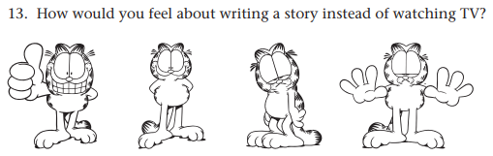
Source: Kear, D. J., Coffman, G. A., McKenna, M. C., & Ambrosio, A. L. (2000). Measuring attitude toward writing: A new tool for teachers. The Reading Teacher, 54(1), 10-23.

Things to notice:
- no numbers are used in either scale
- despite lack of numbers, the scales demonstrate a quantitative response since categories can be sorted by level of happiness or interest
- yet, due to lack of precision of measurement, this scale is at best ordinal

Exercise
Identify the
- variable or variables for each statement/hypothesis,
- indicate whether the variable is categorical or quantitative, and
- identify the scale of measurement for each variable (Nominal, Ordinal, Interval, or Ratio).

(a) Everyone buys a bag of apples, and we each count the number of whole apples in our bags.

Answer Variable is number of apples in a bag and it is quantitative. The scale of measurement is ratio.
- Categories: Count of apples in a bag has distinct categories which are 0, 1, 2, 3, etc.
- Rank: The count can be ranked from less to more, i.e., 7 apples > 6 apples.
- Equal Intervals: Yes, since only the count is considered and not size, weight, or anything else. Thus, the difference between 2 apples and 1 apple is 1 apple. The difference between 15 apples and 14 apples is 1 apple. This count of 1 apple represent the same amount of difference no matter where on the scale (on the count of apples) we place this 1 apple.
- True Zero: There is a true zero point with count, 0 or no apples.

Since count of apples has all four criteria present it is a ratio variable.

Recall that one way to determine whether a variable is ratio is to consider if one can form a logical ratio between two quantities. For example, if I have 5 apples and someone else has 15 apples, then the other person has three times as many apples as I have: 15/5 = 3. Ratios can only be formed with ratio level data.

(b) The classification of people into student groups in high school (e.g., nerds, athletes, and druggies).

Answer These groups represent categories of a categorical variable and therefore it is nominal (no natural rank to these labels; they are simply different groups).

(c) Take the classification used above (nerds, athletes, druggies) and provide a different label now with numbers: group 1, group 2, and group 3.

Answer This variable represents a simple label transformation (nerds = 1, athletes = 2, druggies = 3). Despite using numbers 1, 2, and 3, this is not a quantitative variable. If there is no inherent rank to these categories, changing the labels will not change the scale of measurement. This example illustrates that presence of numbers as a category label does not necessarily make a variable quantitative. A quantitative variable is determined by natural rank to categories or measuring device.

5. Independent/Predictor vs. Dependent/Criterion Variables
The easiest way to identify independent (IV) and dependent (DV) variables is to consider the logical, theoretical, or observed time sequence for the variables.
- Independent/Predictor: variable that comes first in time sequence
- Dependent/Criterion: variable that follows IV in time sequence

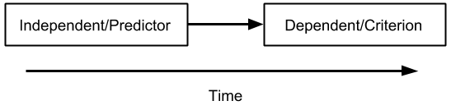
- I use independent variable and predictor synonymously and view dependent and criterion as synonyms too.
- For some an independent variable is one manipulated by a researcher in an experimental study and a dependent variable is that observed after manipulating the independent variable. Thus, use of terms independent and dependent imply causation.
- If variables are not manipulated, or the outcome of manipulation, or if one is studying only relationships, predictions, or correlations, then some argue variables should be called predictors and criterions (or is it criteria?).

Exercise
For each, identify the IV and DV and determine whether each is categorical or quantitative.

(a) Among 3rd grade students, there will be a difference in graded reading performance scores between males and females.

Answer
IV = sex (female/male), Qualitative
DV = reading scores, Quantitative
Reason = one’s sex precedes reading performance scores

(b) Students in larger classes tend to score lower on standardized mathematics tests.

Answer
IV = class size, Quantitative
DV = standardized mathematics scores, Quantitative

(c) Students whose parents are educators will have higher academic self-efficacy than students whose parents are not educators. The academic self-efficacy scale ranges from 5 = low to 15 = high.

Answer
IV = occupation of parents, Qualitative
DV = academic self-efficacy, Quantitative
Sometimes folks think students is a variable; note that it does not vary since the focus of this hypothesis is upon parents of students, not parents of students vs. non-students, so “students” is a constant.

(d) For females in public schools, researchers found that one’s mathematics attitude predicts well one’s mathematics achievement. (Mathematics attitude is a latent variable and is formed as a composite score from responses to several indicators and has a range of 20 = low to 85 = high.)

Answer
IV = mathematics attitude, Quantitative
DV = mathematics achievement, Quantitative

Constants: sex, because there is only one category, female; school setting, because only public schools included, nonpublic schools not included in hypothesis

6. Selecting Basic Statistical Analyses
Many flow charts exist to help researchers identify which statistical tests to use in various situations. Below is one example found on the internet – author unknown.

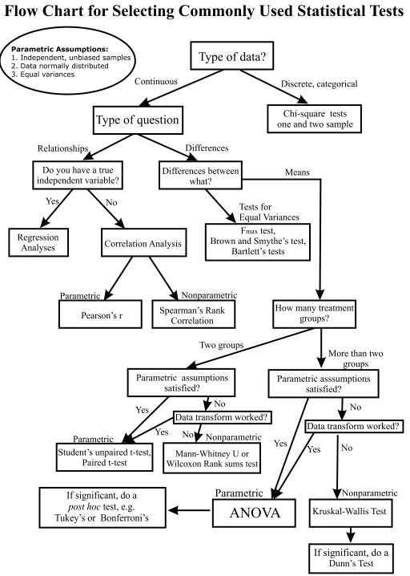
Source: http://abacus.bates.edu/~ganderso/biology/resources/stats_flow_chart_v2014.pdf

Another approach is to consider the number and type of variables one has and then identify tests that fit those variables. The table below identifies the nature of variables for eight analysis procedures taught in EDUR 8131 (Intro. to Statistics).

Statistical Tests Taught in EDUR 8131
Statistical Test | Independent Variable | Dependent Variable | Special Note | Example
One-sample t-test | One Quantitative Variable |  | One variable compared against some set score. | Does Mrs. Jones’ 8th grade PE class weigh more than national mean of 105 lbs.?
Chi-square  Goodness-of-fit | One Categorial Variable |  | One variable, frequencies of category for that variable compared against theoretical (expected) values for those categories. | Is student sex equally distributed within an educational research course (i.e., are there equal numbers of males and females)?
Two independent samples t-test | Categorial  (2 groups) | Quantitative | IV has two groups | Is there a difference in weight between males and females in PE class?
Correlated samples  t-test | Categorial  (2 sets of scores) | Quantitative | Scores are linked or matched in some way across the two sets of scores. | Does the weight of 8th grade students change before and after taking a PE class for one semester?
Pearson r | Quantitative | Quantitative | Works when IV and DV identified, or one wants correlation between two variables that are not identified as IV or DV. | Is there an association between number of hours studied the week before a test and scores obtained on that test?
ANOVA | Categorial  (2 or more groups) | Quantitative | IV has 2 or more groups; mathematically same as two-group t-test if only two groups examined. | Is there a difference in mean weight between 6th, 7th, and 8th grade PE classes?
Linear Regression | Quantitative (Categorial, also) | Quantitative | Provides prediction equation or determines which IVs contribute to modeling DV variation. | Which among house size, age of house, or number of features best predict sale price of a house?
Chi-square  Test of Association | Categorial | Categorial | Are two Categorial (nominal) variables associated? | Do dropout rates differ among three racial groups in Georgia (Black, Hispanic, and White students)? Note that the DV dropout is nominal (in school or out of school).

To use this table, do the following:
1. Identify the variables involved and, if possible, determine which are IV and DV
2. Determine scale of measurement for each variable
3. Determine whether any special circumstances apply (i.e., matched data, 2+ groups).
4. Identify correct statistical test based upon steps 1 through 3 above.

Exercise
For each scenario determine which statistical test would be suitable from among those listed in the table above.

(a) Do females in single-sex classes perform better than females in co-educational classes in high school biology? Below are end of course test scores in 9th grade biology for two classes, one taught with female only and one with both males and females present.

Single-sex  Class |  |  | Co-educational  Class
85 | 75 |  | 79 | 76
83 | 83 |  | 82 | 79
79 | 84 |  | 75 | 81
95 | 86 |  | 94 | 82
71 | 91 |  | 69 | 88
86 | 95 |  | 81 | 84
93 | 98 |  | 87 | 93

Answer
IV Variable: Classroom Composition (single sex vs. coed)
IV Variable Scale of Measurement: Nominal
DV Variable: End of Course Test Scores
DV Variable Scale of Measurement: Likely ratio
Statistical Test: Two groups to compare on quantitative DV so two-group t-test or ANOVA.

(b) Assess the association between recreational reading interest and academic reading interest. Both types of interest are measured with Garfield reading interest subscales which ranges 10 = low to 40 = high (McKenna, M. C., & Kear, D. J. 1990. Measuring attitude toward reading: A new tool for teachers. The reading teacher, 43(9), 626-639.).

Answer
IV Variable: --- Two variables, neither IV nor DV
IV Variable Scale of Measurement: --- Both variables quantitative, multicategory ordinal
DV Variable: ---
DV Variable Scale of Measurement: ---
Statistical Test: Both variables quantitative; relation, not prediction, sought so Pearson correlation appropriate

(c) Does a high school student’s decision to apply for college admission (yes vs. no) differs depending upon whether that student’s mother attended college (yes vs. no)?

Answer
IV Variable: Mother college attendance
IV Variable Scale of Measurement: Nominal
DV Variable: Student’s decision to apply for college
DV Variable Scale of Measurement: Nominal
Statistical Test: Both IV and DV categorical, so chi-square test of association

(d) Foos and Clark (1982) studied the influence of expectations on test performance. They found that the kind of test that a student expected would affect the way in which they studied tested material. Below are scores from an experiment designed to replicate Foos and Clark's research. A total of 20 undergraduate students were given a 3000-word passage to read and were told that they would be tested on that passage. They were then assigned to one of four treatment groups. In the first group, the students were told to expect a multiple-choice test; in the second group, they were told to expect an essay; in the third group, they were told to expect a recall (e.g., fill in blank, matching); and in the fourth group they were not told what to expect. Despite what they were told earlier, all students were given the same test which consisted of multiple-choice and short-answer items. Given below are scores from their test. Is there any evidence that expectation influences performance? (Source: Foos, P. W., & Clark, M. C. (1983). Learning from Text-Effects of Input Order and Expected Test. Human Learning, 2(3), 177-185.)

Type of Test Expected
Multiple-Choice | Essay | Recall | Told Nothing
10 | 12 | 19 | 22
9 | 16 | 23 | 19
7 | 13 | 19 | 18
14 | 15 | 21 | 25
8 | 10 | 23 | 23
Note. Higher scores indicate better test performance.

Answer
IV Variable: Test format expectation
IV Variable Scale of Measurement: Nominal (MC, essay, matching and short-answer, told nothing)
DV Variable: Test Scores
DV Variable Scale of Measurement: Likely ratio
Statistical Test: ANOVA since the IV is categorical with more than two categories and DV is quant.

(e) Lynch and Dembo (2004) sought to learn whether (a) Intrinsic Goal Orientation, (b) Self-efficacy for learning and performance, (c) Time and Study Environment, (d) Help Seeking, (e) Internet Self-efficacy, and (f) Verbal Ability predict (g) Final Course Grades. Lynch and Dembo used scales to measure each variable and the scales produced ranked scores such that higher scores indicate more of that measured variable. (Lynch, R., & Dembo, M., 2004, The relationship between self-regulation and online learning in a blended learning context. International Review of Research in Open and Distributed Learning, 5.)

Answer
IV Variable: Variables (a) through (f) are predictors, hence IVs
IV Variable Scale of Measurement: All are quantitative
DV Variable: Final Course Grades
DV Variable Scale of Measurement: Likely ratio
Statistical Test: Regression since they wish to know whether each of (a) through (f) predict Final Couse Grades

(f) Does premium gasoline (octane of 91) result in better miles per gallon (MPG) than regular gasoline (octane of 87) for typical cars? To test this question, seven cars were filled separately with both types of gasoline and driven on a closed track until the tank emptied. Below are results for MPG under both types of gasoline for the same car. Is there any evidence that one gasoline octane level produced better MPG than the other?

 | MPG for Premium Gas | MPG for Regular Gas
Honda Accord | 31.3 | 32.5
Honda Civic | 38.7 | 38.8
Ford Taurus | 22.6 | 22.7
Buick Regal | 23.3 | 23.2
Toyota Camry | 28.9 | 29.1
Dodge Avenger | 21.5 | 21.4
Toyota RAV4 | 26.8 | 26.9

Answer
IV Variable: Type of Gas
IV Variable Scale of Measurement: Categorical (Premium vs. Gas)
DV Variable: MPG
DV Variable Scale of Measurement: Ratio
Statistical Test: Correlated t-test since gas observations are matched by car

(g) Is there a difference in level of recreational reading interest between students at Portal Elementary School and Brooklet Elementary School? Recreational reading interest is measured using the Garfield reading interest scale which ranges from 10 = low to 40 = high (McKenna & Kear, cited above).

Answer
IV Variable: School (Portal vs. Brooklet)
IV Variable Scale of Measurement: Nominal
DV Variable: Recreational reading interest
DV Variable Scale of Measurement: Multicategory ordinal
Statistical Test: Two groups to compare on quantitative DV so two-group t-test or ANOVA.

(h) Who goes to the local library? Library patrons are asked to complete a brief questionnaire that elicits various demographic variables. One variable is patron sex. Library researchers anticipated a 50/50 split between male and female patrons, but actual numbers show the distribution is 63 females and 37 males. How could this difference be tested against the expected 50/50 distribution?

Answer
IV Variable: ---
IV Variable Scale of Measurement: ---
DV Variable: Sex
DV Variable Scale of Measurement: Nominal
Statistical Test: Only one nominal variable so chi-square goodness of fit.

(i) Is there a change in level of recreational reading interest, using the Garfield scale (range 10 = low to 40 = high), before and after students visit a library?

Answer
IV Variable: Type of Gas
IV Variable Scale of Measurement: Categorical (Premium vs. Gas)
DV Variable: MPG
DV Variable Scale of Measurement: Ratio
Statistical Test: Correlated t-test since gas observations are matched by car

(j) Laser toner cartridges for the Hewlett-Packard LaserJet 1200 series are estimated to last approximately 2000 pages per cartridge assuming 5% coverage per page. To test this advertising claim, 15 toner cartridges were purchased and installed in 15 HP LaserJet 1200 printers throughout a school district. Number of pages was recorded for each cartridge until visible lines of non-print became apparent. Below are the number of pages recorded. Is there any evidence that the advertisers' claim of 2000 pages is supported?

Number of pages recorded: 1985, 1675, 1548, 1756, 1865, 1235, 1498, 1195, 1611, 1754, 2056, 1454, 1332, 1444, and 1669

Answer
IV Variable: ---
IV Variable Scale of Measurement: ---
DV Variable: Number of pages printed
DV Variable Scale of Measurement: Ratio
Statistical Test: One quantitative variable compared against a defined standard so one-sample t-test.

(k) Does the racial/ethnic distribution of our sample match the expected population distribution, i.e., are the sample and population frequencies or percentages consistent?

Answer
IV Variable: ---
IV Variable Scale of Measurement: ---
DV Variable: Race/Ethnicity
DV Variable Scale of Measurement: Nominal
Statistical Test: Only one nominal variable so chi-square goodness of fit.

(l) Self-determination theory (SDT) is an explanation for motivation that contains three fundamental constructs: autonomy, relatedness, and competence (Deci & Ryan, 1985). Briefly explained, autonomy refers to individual power and control over important decisions, relatedness is a want for interaction and social experience with others, and competence refers to one’s ability to successfully interact with daily tasks and demands. SDT has been applied in many settings including work, well-being, and education. Ntoumanis (2001) examined whether SDT would prove beneficial for motivating students in psychical education (PE). These three constructs were measured with scales composed of several Likert-type items (1 = Strongly Disagree to 5 = Strongly Agree):
- Autonomy in PE by measuring student level of choice (e.g., “I can decide which activities I want to practise in this PE class”)
- Relatedness in PE by assessing social fit (e.g., “Taking part in this PE class makes me feel closer to the other students”)
- Competence in PE by examining skill (e.g., “I am pretty skilled at the activity/sport in this PE class”)

SDT suggests that autonomy, relatedness, and competence should be positively related. Below are fictional data that mimic that obtained by Ntoumanis. Which statistical analysis could be used to examine these possible relations?

Sources:
Deci, E.L., & Ryan, R.M. (1985). Intrinsic motivation and self-determination in human behavior. New York: Plenum.
Ntoumanis, N. (2001). A self‐determination approach to the understanding of motivation in physical education. British journal of educational psychology, 71(2), 225-242.

student | autonomy | relatedness | competence
1 | 5 | 5 | 8
2 | 11 | 12 | 12
3 | 16 | 12 | 14
4 | 11 | 12 | 11
5 | 7 | 13 | 14
6 | 13 | 17 | 12
7 | 9 | 10 | 11
8 | 6 | 6 | 7
9 | 9 | 14 | 9
10 | 13 | 8 | 8

Answer
IV Variable: --- Three variables, none IV nor DV
IV Variable Scale of Measurement: --- All variables quantitative, multicategory ordinal
DV Variable: ---
DV Variable Scale of Measurement: ---
Statistical Test: Relation, not prediction, sought so Pearson correlation appropriate

(m) Do student-teacher ratio and average teacher salary simultaneously predict student performance on the mathematics section of the SAT across the 50 states and DC? Which of these variables is the better predictor, if either, once the other is controlled or taken into account? The data for this study are real and were obtained from the College Board website and various national educational websites; the three variables of interest are:
- math_sat: Average mathematics SAT scores in each state.
- pupil_teacher_ratio: Average ratio of students to teacher in each state; a higher number indicates more students per teacher
- average_teacher_salary: Average salary per teacher in each state in thousands of dollars, thus a figure of 25.000 means the average salary per teacher is $25,000 per year
Analyze these data statistically to determine the predictive nature of pupil-teacher ratio and average teacher salary for predicting mathematics performance on the SAT.

Answer
IV Variable: Student-teacher ratio and Average Teacher Salary
IV Variable Scale of Measurement: Both ratio
DV Variable: SAT Scores
DV Variable Scale of Measurement: Likely multicategory ordinal
Statistical Test: Regression since we wish to know whether the IVs predict the DV

7. SPSS: Data Entry

Data Entry
SPSS has a data entry screen that is similar to a spreadsheet. Before entering data, first ensure select Data View is selected.

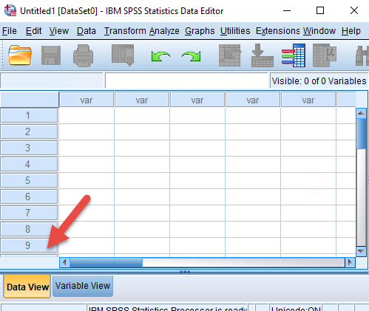

Enter the following data into SPSS; a screenshot below shows entered data.

Scores | Sex | Sex as Number
1 | F | 0
2 | F | 0
3 | F | 0
4 | M | 1
5 | M | 1
5 | M | 1

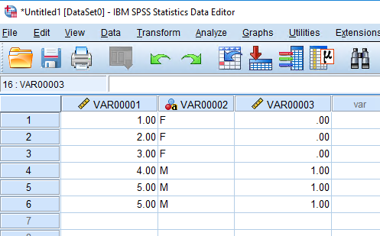

The image above shows different symbols for columns VAR00001 and VAR0002; the different symbols indicate Numeric data (the ruler) and String data (blue and red circles and letter a). String data are typically letters and words. Variable data type – numeric or string – can be changed using Variable View.

Next select Variable View so variable names and labels, and Value labels, can be added, if desired.

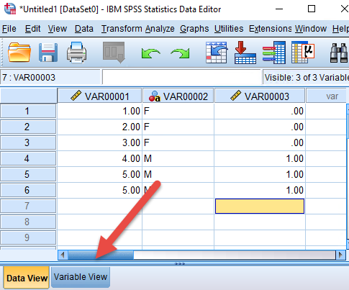

Enter variable names in the first row.

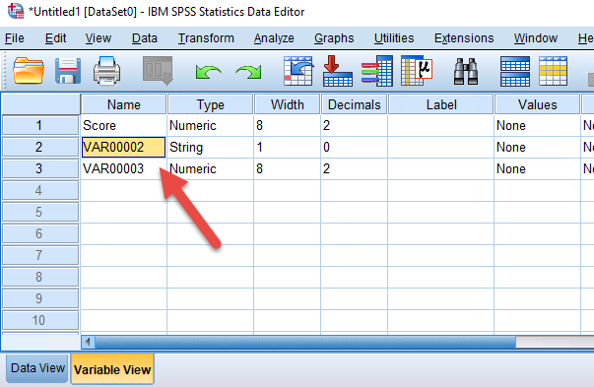

Value labels can also be added to help provide description to variable categories.

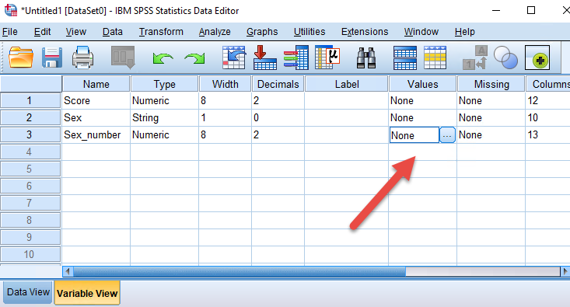

For the variable of interest (Sex_number in the above example), click on the “…” under the Values column to access a menu to add labels. First identify the Value (e.g., 1) then enter the Label (e.g., Male), then click Add. Click OK once all labels are added.

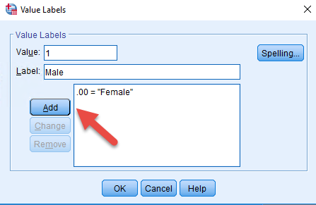

When labels are added to values, labels are displayed in SPSS results. As an example, run Frequencies on the three variables entered.

Analyze → Descriptive Statistics → Frequencies

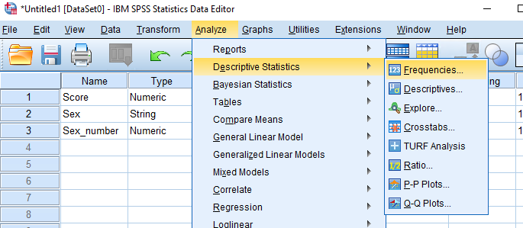

Highlight and move each variable to the Variables box, then click OK to see results.

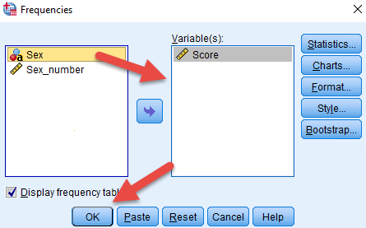

Below are Frequency tables; note the displayed labels Female and Male that were added to the Sex_number variable.

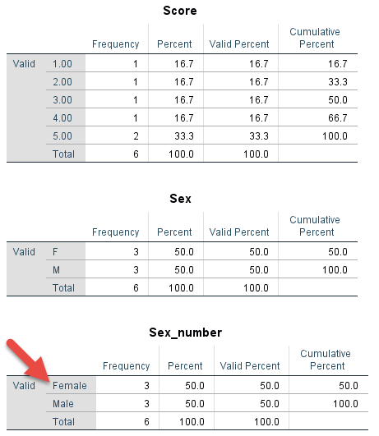

8. Qualtrics: Exporting Data for SPSS
Screenshots below illustrate how to export Qualtrics data in an SPSS file format.

(a) Select the survey to download.

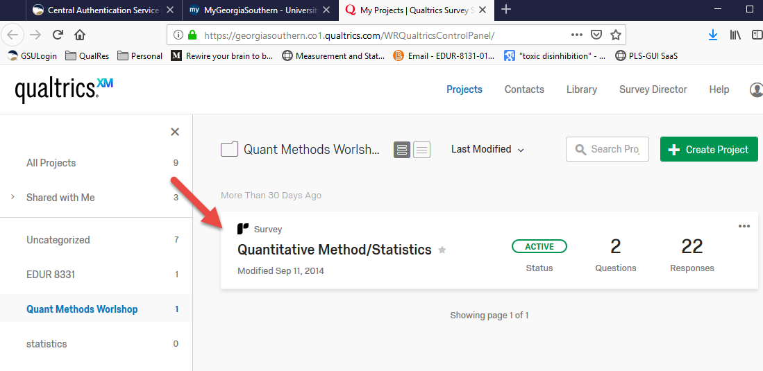

(b) Select “Data & Analysis” from the top menu, the select “Export & Import” from the submenu.
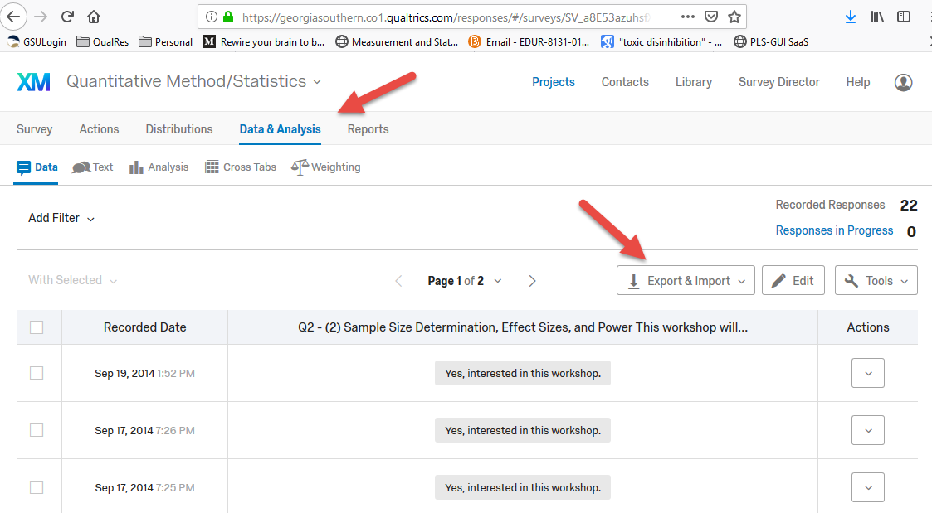

(c) Select Export Data

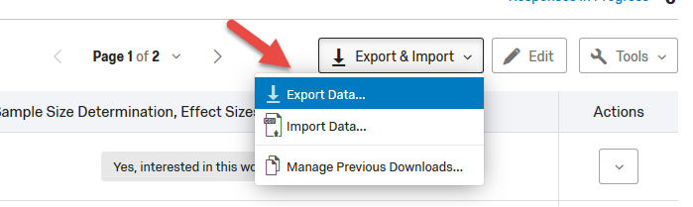

(d) Lastly, choose SPSS then click Download to obtain a Qualtrics generated SPSS file.

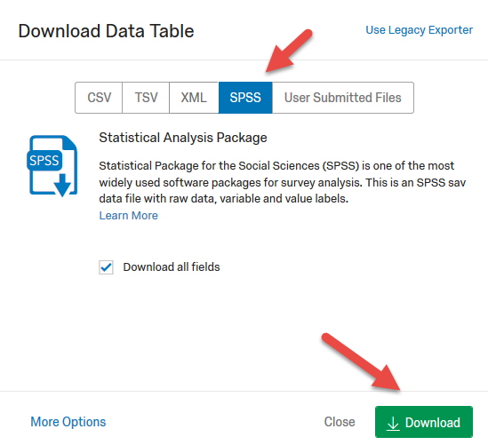

9. SPSS: Frequency Displays and Descriptive Statistics
Frequencies can be helpful for seeing data distributions and identifying data entry errors or problematic coding.

The examples that follow use an SPSS data file located in the link below. If SPSS is installed on your computer, it should launch automatically once these data are downloaded.

http://www.bwgriffin.com/workshop/2019Sp-workshop-data.sav

Most of these data were taken from two studies conducted at Georgia Southern. The first included both undergraduate and graduate students and attempted to learn of their social media usage. The second studied cyber-harassment experiences of undergraduate students. Two variables, MPG and Vehicle_weight, were taken from a 1970s study of autos, and two other variables, Test2_PerentCorrect and Test2_SecondsPerItem, were data obtained from an educational research course in the early 2000s.

Questionnaire items
(a) What is your race/ethnicity? ____________

Workshop SPSS variable = Race_Ethnicity. This item was taken from the social media study.

Coded response options
1 = American Indian or Alaska Native
2 = Asian
3 = Black or African American
4 = Hawaiian or Pacific Islander
5 = Hispanic/Latino
6 = White
7 = Mixed/Multi-racial

SPSS Frequency result for Race_Ethnicity

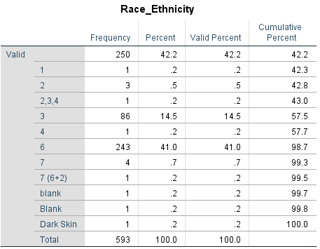

The frequency table above shows some unexpected responses (e.g., “2,3,4” and “Dark Skin”); item revision may be the number of unexpected responses is large.

(b) Who can see your social media?

Workshop SPSS variable = See_Social_Account. This item was taken from the social media study.

The questionnaire item and category coding (in red) are presented below.

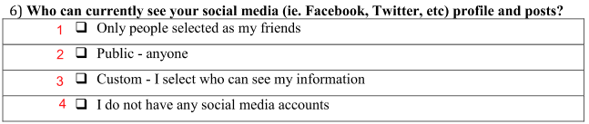

SPSS Frequency result for See_Social_Account

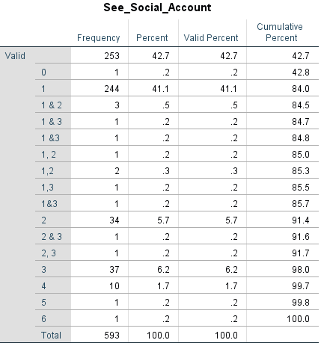

Note the codes of 0, 5, and 6, which are not possible; these are likely data entry errors. Also, multiple categories were selected, and this suggests item revision is needed to reduce this problem with future administrations of this item.

(c) What is your age? _________

Workshop SPSS variable = Age. This item was taken from the social media study.

Below are two tables, one showing descriptive statistics for Age, and the second showing the frequencies for Age.

Since Race/Ethnicity and See Social Media are String variables in SPSS – due to incorporation of letters in responses – descriptive statistics are not calculated for these variables. If descriptive statistics were calculated, they would be mostly meaningless for nominal data.

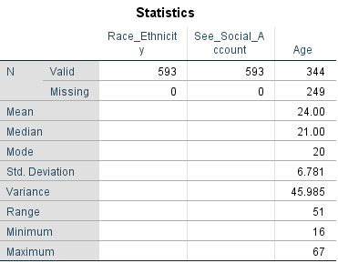 | 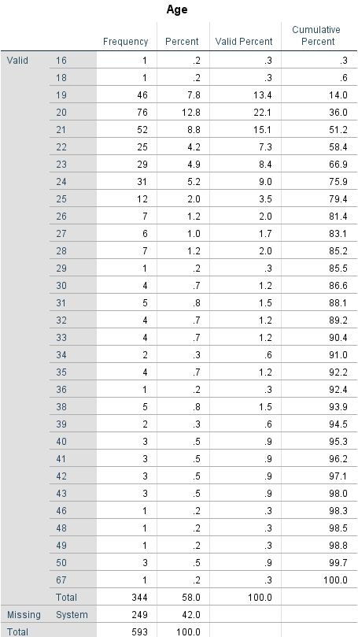

10. SPSS: Graphical Displays
Graphical displays can be helpful for visualizing and relating data to others. They can also be helpful for identifying problematic data (e.g., outliers) and unusual relationships.

Bar Charts
Bar Charts provide a visual depiction of frequencies for nominal variables.

Workshop SPSS variable = Harrassment_Group4; item from the cyber-harassment study.

What is the distribution of perpetrator and victim experience with cyber-harassment among GSU undergraduate college students?

Cyber-harassment experience while in college was measured by responses to items that assess victim and perpetrator roles for five different types of online harassing formats. Each are listed below.

Were you a victim of  - Spoken Harassment  - Written Harassment  - Visual Harassment  - Hacking or Impersonation  - Social Harassment | Did you do any of the following to someone  - Spoken Harassment  - Written Harassment  - Visual Harassment  - Hacking or Impersonation  - Social Harassment

Responses to these queries were then grouped into four categories, which are displayed in the bar chart below.

SPSS Commands to obtain a bar chart for Harrassment_Group4. Select Bar under Graphics, then Legacy Dialogs. Next select Simple for Bar Chart type, then click on Define.

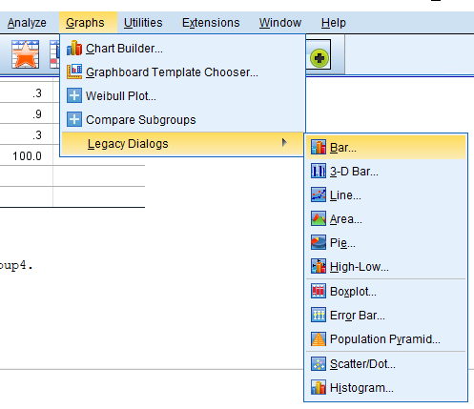 | 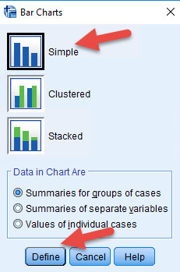

Next identify the variable of interest and move it to the Category Axis box, then select OK to obtain the Bar Chart.

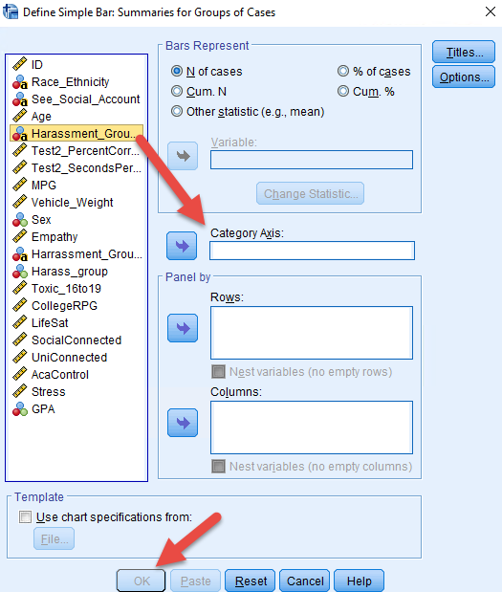

Below is the bar chart for Harrassment_Group4. Note that over 300 (58%) of the 593 respondents indicated they were not involved in any type of cyber-harassment while in college. About 122 (21%) were victims of cyber-harassment, 115 (19%) were both victim and perpetrator, and only 13 (2%) were perpetrator only. This suggests that most who perpetrate cyber-harassment in college are also victims of cyber-harassment.

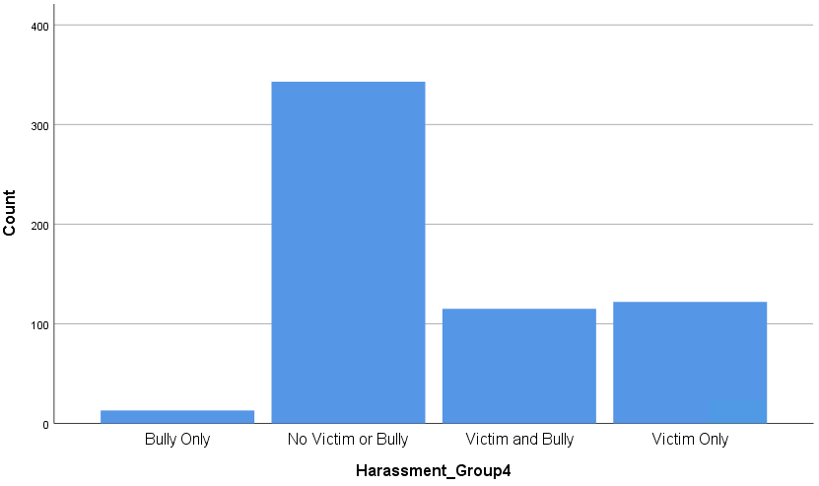

Histograms
Histograms are the quantitative counterpart to bar charts. The primary difference is that with histograms the bars may touch thus signifying that the categories are consecutive whereas with bar chats the bars do not touch which indicates the categories are not consecutive and therefore may be presented in any order without changing the meaning of the data.

Workshop SPSS variable = Age (part of social media study).

What is the distribution of age for those who provided Race/Ethnicity data?

For this graph we will use a dot-plot which is similar to a histogram but uses dots instead of bars to show frequencies.

Select Graphs, Legacy Dialogs, then Scatter/Dot.

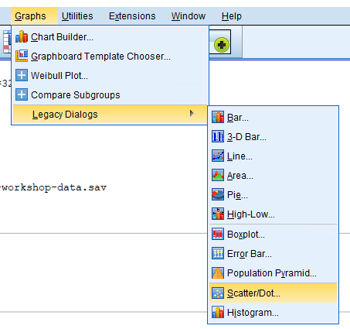

Next, select Simple Dot then Define.

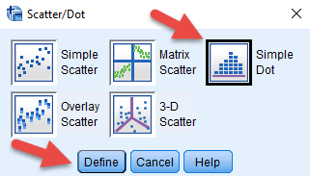

Next, more Age to the X-Axis Variable box, then click OK to obtain the dot plot.
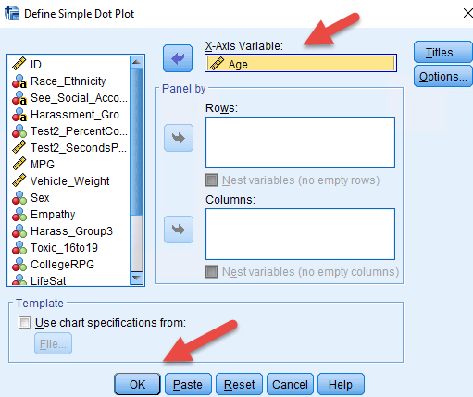

The dot plot is shown below. Most respondents were 19 to 25. One was over 60. The older respondents were likely part of the graduate student sample.

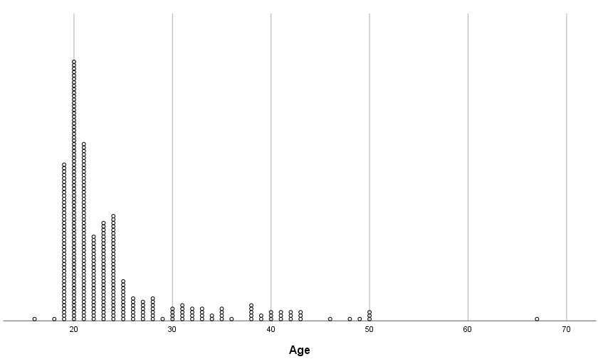

Scatterplot: Test Cheater?
Scatterplot are helpful for showing relations among quantitative variables. They are also helpful for identifying outliers or unusual cases.

Workshop SPSS variable = Test2_PerentCorrect and Test2_SecondsPerItem

Does time taken to complete test items (Test2_SecondsPerItem) correlate with test scores (Test2_PerentCorrect) for students in EDUR 7130 (Intro to Research)?

After selecting Scatter, select Simple Scatter, then Define.

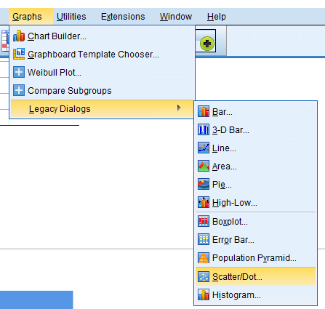 | 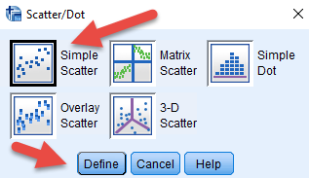

Next move Test2_PerentCorrect into the Y Axis box and Test2_SecondsPerItem to the X Axis box, then click OK to obtain the scatterplot.

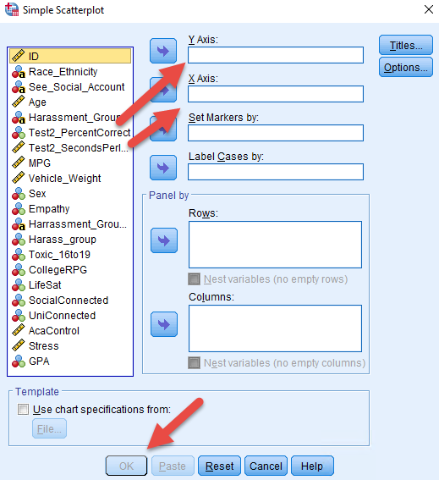

The scatterplot shows that most students took about 2 or more minutes per item (120 seconds or more), but one student was able to complete item in about 40 seconds, on average, and was able to obtain a score near 100. This student’s performance clearly differs from others and suggests something odd – maybe knowledge of the test before it was administered.

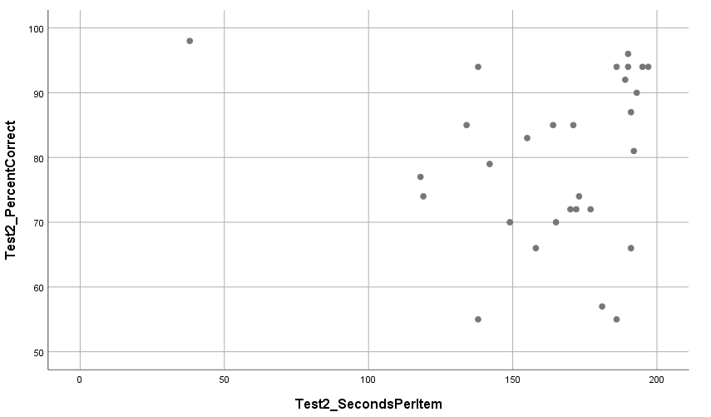

Scatterplot: Nonlinear Relation
With this example we will use two automobile related variables: MPG and Vehicle_Weight.

What is the visual relation between vehicle weight and miles per gallon (MPG)?

As above, select Scatter from the Graphs command, then move MPG to the Y Axis and Vehicle_Weight to the X Axis. Click OK to obtain the scatterplot.
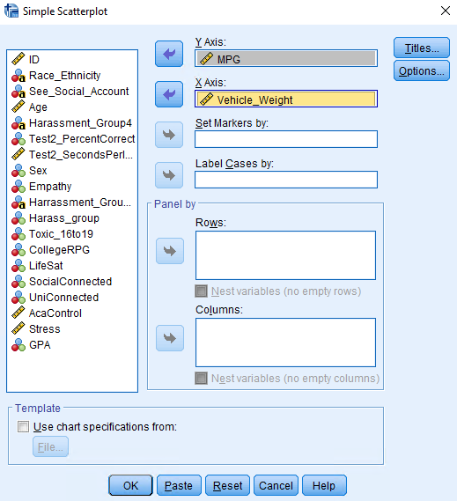

The scatterplot shows that there is a general negative relation between MPG and vehicle weight: as weight increases, MPG declines. The relation also appears to have a nonlinear component with a slight curve occurring with weights between 2000 and 2750. Note that these data are from model years 1970 to 1982. As the plot shows, several cars during this time period were able to achieve 30+, and even 40+, MPG.

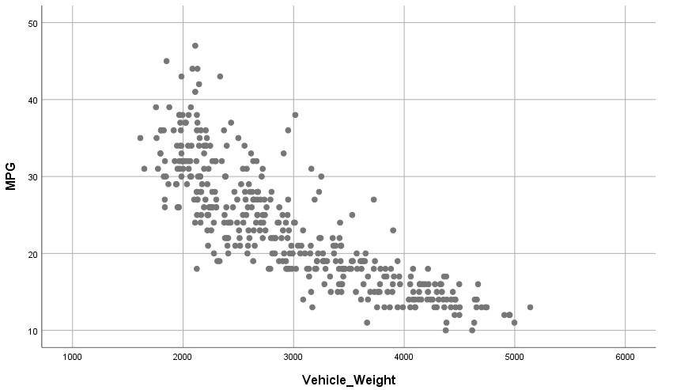

11. SPSS: Two-group t-test (Empathy Differences by Sex)
The t-test can be used to compare mean scores on a quantitative DV between two groups (the groups form the IV).

For this example, we will use two variables from the SPSS data file: Sex and Empathy. These data come from the cyber-harassment study.

Does empathy differ by sex for GSU college students?

Empathy was measured by taking a mean composite score for responses to the following four items.

 | Strongly Disagree | Disagree | Mix of Disagree and Agree | Agree | Strongly Agree
30. If a classmate is teased, I feel bad thinking about what is happening to him/her. | 1 | 2 | 3 | 4 | 5
31. I am patient with people who do things worse than I do. | 1 | 2 | 3 | 4 | 5
32. I feel the misfortunes of others. | 1 | 2 | 3 | 4 | 5
33. When I see that a friend is sad, I also become sad. | 1 | 2 | 3 | 4 | 5

Source for empathy items: Álvarez-García, D., Barreiro-Collazo, A., Núñez, J. C., & Dobarro, A. (2016). Validity and reliability of the Cyber-aggression Questionnaire for Adolescents (CYBA). The European Journal of Psychology Applied to Legal Context, 8(2), 69-77.

SPSS commands – Analyze, then Compare Means, then select Independent Samples t-test

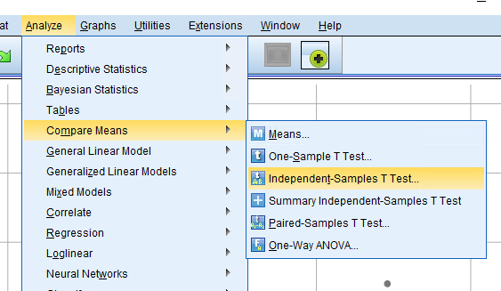

Next, move the Empathy variable to the Test Variables box, and move Sex to the Grouping Variables box.

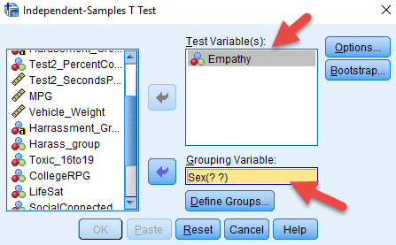

Click on Define Groups and indicate the category numbers for the two groups involved. For these data, Sex is coded as follows:
1 = female
2 = male.

Once groups are identified in the Define Groups box, click Continue then OK to run the analysis.

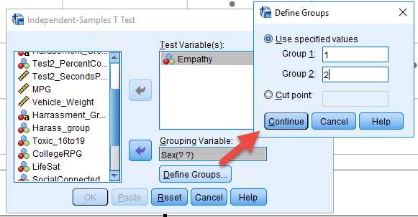

SPSS results are presented below. First, the Group Statistics table shows the mean, standard deviation, sample size, and standard error of the mean for both groups. Note that males, group 2, have a lower mean Empathy score than females. The t-test helps us judge whether this observed mean difference is likely due to chance or a real difference between females and males.

The calculated t-value is 6.88 with a p-value of .000 which is less than traditional alpha levels of .05 and .01, so the null hypothesis of no mean difference in empathy between females and males can be rejected. This suggests the observed sample difference in empathy is likely due to a real difference in empathy between females and males. Females appear to demonstrate more empathy for others than males.

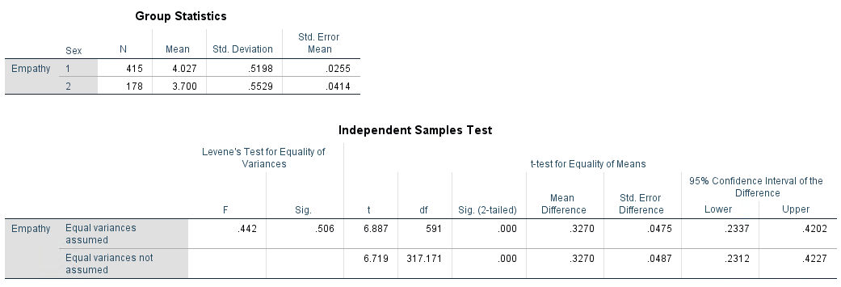

12. SPSS: ANOVA (Toxic Online Disinhibition and Cyber-harassment Groups)
ANOVA is mathematically identical to the t-test when a quantitative DV is compared between two groups. The benefit of ANOVA is that it can be more efficient, when compared to multiple t-tests, to compare more than two groups.

This example will use two variables from the SPSS data file: Harass_Group3 and Toxic_16to19. These data come from the cyber-harassment study.

Harass_Group3 consists of three groups:
- Bullies and Victims
- Victims Only
- Neither Bully nor Victim (i.e., no cyber-harassment experience in college)
- The fourth group, Bullies Only, shown earlier was dropped from this analysis due to small sample size.

Toxic_16to19 is the label for toxic online disinhibition and refers to the extent to which one believes or feels free to engage in toxic, mean-spirited behavior while online. It is a composite variable formed from responses to four items, shown below. The composite was created by taking the mean of the four items for each respondent.

 | Strongly Disagree | Disagree | Mix of Disagree and Agree | Agree | Strongly Agree
16. I don’t mind writing insulting things about others online, because it’s anonymous. | 1 | 2 | 3 | 4 | 5
17. It is easy to write insulting things online because there are no repercussions. | 1 | 2 | 3 | 4 | 5
18. There are no rules online therefore you can do whatever you want. | 1 | 2 | 3 | 4 | 5
19. Writing insulting things online is not bullying. | 1 | 2 | 3 | 4 | 5

To begin the analysis, select Analyze, Compare Means, then One-way ANOVA.

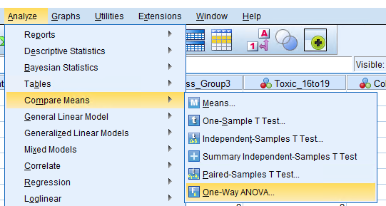

Next, move the DV, Toxic_16to19, to the Dependent List, and move the IV, Harass_Group3, to the Factor box. Then click on Options and Post Hoc.

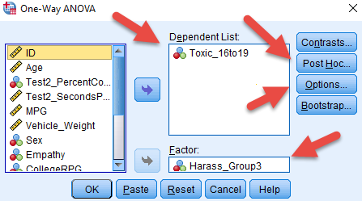

In Options, place a check mark next to Descriptive so means and standard deviations are provided for each group.

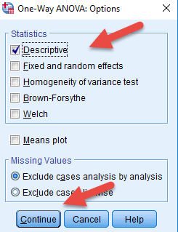

In the Post Hoc window, place a mark next to Bonferroni as the multiple comparison procedure used for comparing means across the three groups.

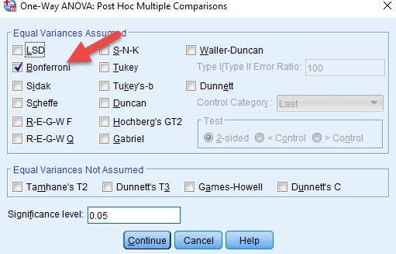

Click Continue then OK to run the analysis.

Results are presented below. The Descriptives table shows the means for each of the three groups. Given theory and prior research, one would expect those who engage in cyber-harassing behaviors would likely display higher levels of agreement with toxic online disinhibition; that is, bullies should feel freer to harass others than victims or those who have not experienced cyber-harassment. The means show this to be the case – bullies have higher toxic disinhibition scores than the other two groups.

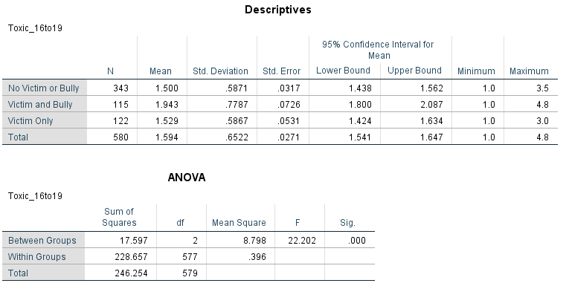

The ANOVA summary table shows an F ratio of 22.20 with a corresponding p-value of .000 which is less than alpha values of .05 and also .01, so the F ratio is significant which means the null hypothesis of no mean differences in toxic disinhibition among the three groups is rejected.

The multiple comparisons table below shows which group means differ. Results show the Victim and Bully group had means that were statistically higher than the No Victim/Bully group and the Victim Only group. In short, bullies had higher toxic disinhibition scores than the other respondents.

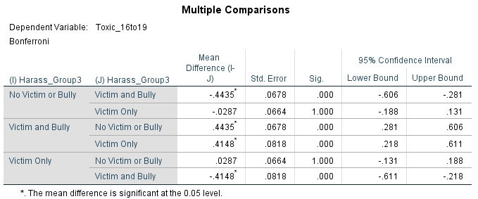

13. SPSS: Pearson Correlation (College RPG Convergent Validity Evidence)
Pearson correlation coefficient, r, can be used to assess the strength of linear relation between quantitative variables. Pearson r ranges from -1 (perfect negative relation) to 1 (perfect positive relation). Values closer to 0.00 indicate no linear relation or weak linear relation.

This analysis example will use seven variables from the SPSS data file; all come from the cyber-harassment study.

- CollegeRPG: A measure of student’s progression and likely graduation from college. The four items listed below form this scale.

 | No or almost never | Rarely | Sometimes | Often | Almost Always
4. Do you think about dropping out of university/college? (Reversed) | 1 | 2 | 3 | 4 | 5
5. Do you think about transferring to another university/college? (Reversed) | 1 | 2 | 3 | 4 | 5
6. Do you think about taking a break from university/college studies for a while and maybe returning later? (Reversed) | 1 | 2 | 3 | 4 | 5

 | Not at all Confident | Slightly Confident | Moderately Confident | Mostly Confident | Extremely Confident
7. How confident are you that you will graduate from a university/college? | 1 | 2 | 3 | 4 | 5

Convergent validity is assessed by examining empirical relations among constructs that should be theoretically correlated. If the anticipated relations are found, this suggests the scales are measuring what they were designed to measure. The more relations examined and supported, the stronger the evidence of convergent validity.

In this example the goal is to examine evidence of convergent validity for scores obtained from the College RPG scale. Six constructs will be used to assess validity evidence of College RPG. Note that each construct listed below is answered within the context of college life.

- LifeSat: Life satisfaction.
  - Example: In most ways my life is close to ideal.
- SocialDisconnected: Socially disconnected, an indication of lack of social relations.
  - Example: Other people seem to have more friends that I do.
- UniConnected: University Connectedness, a since of belonging to the university environment.
  - Example: I am happy to be at this university.
- AcaControl: Academic Control, perceived ability to influence one’s academic behavior.
  - Example: No matter what I do, I can’t seem to do well in my courses.
- Stress: Kessler distress index, inability to cope with stressful situations.
  - Example: Since you started college, how often did you feel hopeless?
- GPA: Self-reported student grade point averages.

Complete scale items and citations for each of the above variables are provided in the appendix.

Since these correlations will be used to assess convergent validity evidence for the College RPG scale, it is necessary to form predictions about the nature of the correlations prior to calculating Pearson r values. Predictions are provided below; theoretical rational for each prediction is not included here. Also included are few predictions about which correlations should be stronger since these select constructs are more closely aligned with academic functioning.

- CollegeRPG and LifeSat: Positive
- CollegeRPG and SocialDisconnected: Negative
- CollegeRPG and UniConnected: Positive - stronger
- CollegeRPG and AcaControl: Positive - stronger
- CollegeRPG and Stress: Negative
- CollegeRPG and GPA: Postive - stronger

To obtain correlations, use Analyze, Correlate, then Bivariate.

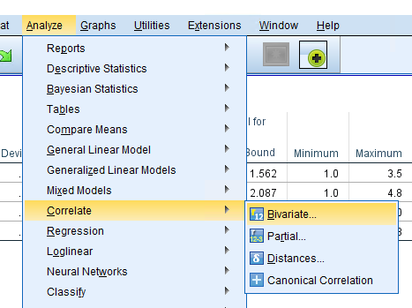

Next select each of the study variables and move them to the Variables box. Tip – include the key variable first, CollegeRPG, because it is easier to read the table of correlations for this variable if listed first.

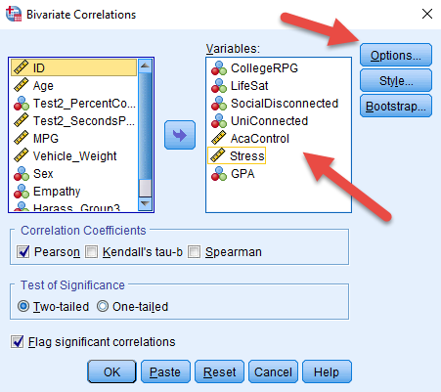

Click on the Options box and place a check next to Means and standard deviations to obtain descriptive statistics for each variable. The click on Continue and OK to obtain results.

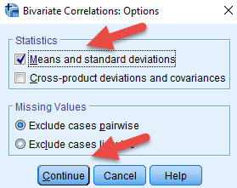

SPSS results are provided below. The Descriptive Statistics table shows M, SD, and N for each variable.

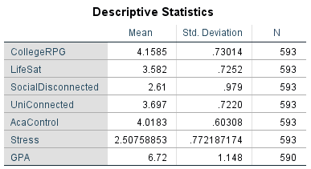

The Correlations table contains the information of interest for this study. How well does College RPG correlate with each criterion? Correlations are reproduced next to each prediction below and all are statistically significant at the .01 level.

- r = .39 CollegeRPG and LifeSat: Positive
- r = -.23 CollegeRPG and SocialDisconnected: Negative
- r = .48 CollegeRPG and UniConnected: Positive - stronger
- r = .38 CollegeRPG and AcaControl: Positive - stronger
- r = -.34 CollegeRPG and Stress: Negative
- r = .30 CollegeRPG and GPA: Postive - stronger

The directions of correlations (positive vs. negative) were consistent with expectations. Two of the three strongest correlations were as expected, University Connectedness and Academic Control, but Life Satisfaction was more strongly correlated with College RPG than anticipated. Overall the results provide good evidence for the convergent validity of the College PRG scale.

The SPSS Correlations table presents three bits of information for each bivariate relation examined: Pearson r value, p-value for the correlation (labeled as “Sig. (2-tailed”), and sample size (N). Examples of reading information from the table follows.

Example 1
Correlation between College RPG (CollegeRPG) and Life Satisfaction (LifeSat)

- r = .394** (correlation is .394 hence positive, the ** means it is significant at .01 level)
- Sig (2-tailed) = .000 (p-value is .000; p-value is compared against alpha for hypothesis testing)
- N = 593 (sample size for correlation)

Example 2
Correlation between Grade Point Average (GPA) and Distress (Stress)

- r = -.086* (correlation is -.086 hence weak and negative, * means it is significant at .05 level)
- Sig (2-tailed) = .038 (p-value is .038; p-value is compared against alpha for hypothesis testing)
- N = 590 (sample size for correlation)

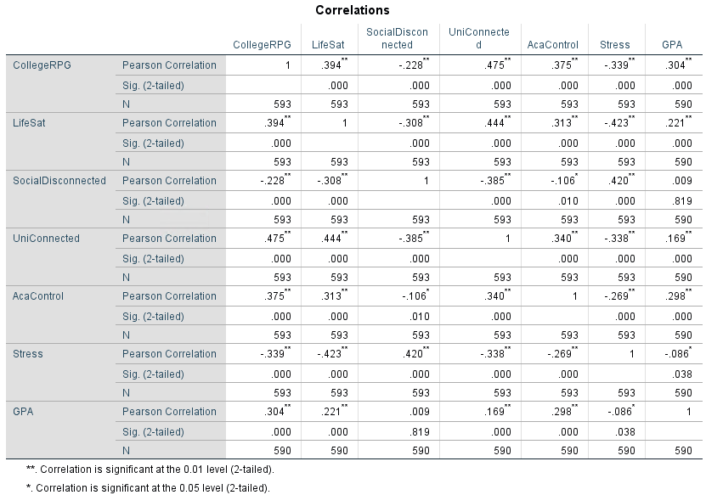

Appendix

LifeSat, SocialDisconnected, and UniConnected were measured by the items listed below. Sources for each are also listed below.

Diener, E. D., Emmons, R. A., Larsen, R. J., & Griffin, S. (1985). The satisfaction with life scale. Journal of personality assessment, 49(1), 71-75.

Schreiner, L. A., Pothoven, S., Nelson, D., & McIntosh, E. J. (2009, November). College student thriving: Predictors of success and retention. In annual meeting of the Association for the Study of Higher Education, Vancouver, British Columbia.

Thompson, D. R., Iachan, R., Overpeck, M., Ross, J. G., & Gross, L. A. (2006). School connectedness in the health behavior in school‐aged children study: the role of student, school, and school neighborhood characteristics. Journal of School Health, 76(7), 379-386.

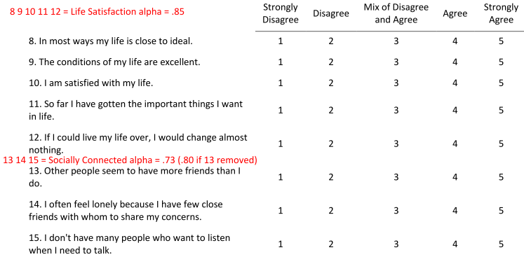
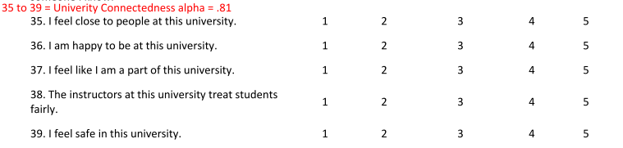

The Academic Control Scale, AcaControl, was used and consists of the following eight items.

Stupnisky, R. H., Renaud, R. D., Daniels, L. M., Haynes, T. L., & Perry, R. P. (2008). The interrelation of first-year college students’ critical thinking disposition, perceived academic control, and academic achievement. Research in Higher Education, 49(6), 513.

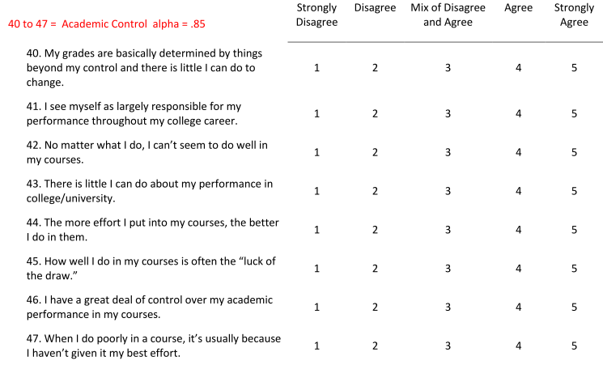

The Kessler distress scale, short form K6, was used to measure distress. Items appear below.

Kessler, R. C., Andrews, G., Colpe, L. J., Hiripi, E., Mroczek, D. K., Normand, S. L., ... & Zaslavsky, A. M. (2002). Short screening scales to monitor population prevalences and trends in non-specific psychological distress. Psychological medicine, 32(6), 959-976.

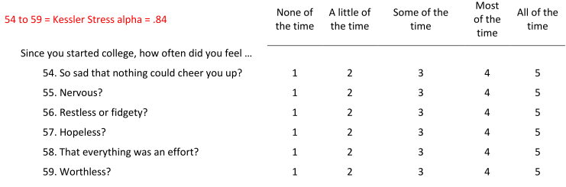

Lastly, GPA was measured by the following item.

